WOODLAND HOLLOW LEARNING CENTER
20 Iron Mountain Road, Warwick, NY 10990 (845) 986-9959

Come and join us for some summer fun!

Summer Camp 2021 – Ages 3-5

Camp will meet 4 days a week – Monday through Thursday from 9:30-12:00. Weather permitting, our camp activities will be held outdoors. You may sign up for one week, or multiple weeks. Campers must bring their own snack and water each day! Put a checkmark in front of the weeks in which you are interested.

_______Week 1: July 11 - July 14

Treasure Island Search for pirates and create treasure maps!

______Week 2: July 18 - July 21
Under the Big Top A circus themed week with lots of circus fun!

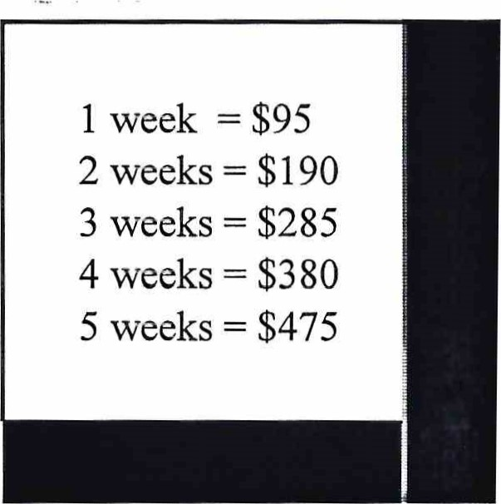
_______Week3: July 25 - July 28
The Mighty Jungle Learn how to rumble in the jungle!
_______Week 4: August 1 - August 4
Under the Sea Discover the world under the Sea!

_______Week 5: August 8 - August 11
A Bug's Life Create some friendly bugs and their ecosystems!

Child's name _________________________________________________ (circle one) Boy Girl

Parents' names _____________________________________________________________________

Mailing Address ____________________________________________________________________

E-mail Address _____________________________________________________________________

Telephone number ____________________________ Child's birthdate _______________________
**** Return this entire form with your tuition payment ASAP. Don’t miss out on the fun! ****

